**How to upgrade RK3288 Android firmware ？**

1.Unzip the file C:\Users\Administrator\AppData\Roaming\Tencent\Users\2853232053\QQEIM\WinTemp\RichOle\2DYGO@PCQ37U9U12[B81PZI.pngand get the file C:\Users\Administrator\AppData\Roaming\Tencent\Users\2853232053\QQEIM\WinTemp\RichOle\N2@ALS)E1SZAGSFO5QVD[4Y.png . Install the software under this folder C:\Users\Administrator\AppData\Roaming\Tencent\Users\2853232053\QQEIM\WinTemp\RichOle\0Q7O%{DWMIXO[IKPMPR6IIE.png,click program ***DriverInstall*** C:\Users\Administrator\AppData\Roaming\Tencent\Users\2853232053\QQEIM\WinTemp\RichOle\MKGDGMK1`2(CIW_VX`0JO}L.png and get this pop-up

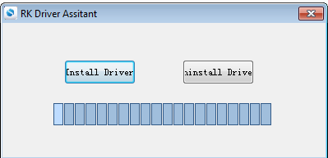

Click ***Install Driver***

1. Download Android system in IMG format

C:\Users\Administrator\AppData\Roaming\Tencent\Users\2853232053\QQEIM\WinTemp\RichOle\U4`_FYD9]ID)(SV2DIQUMK9.png

Start the ***AndriodTool*** you have installed.

C:\Users\Administrator\AppData\Roaming\Tencent\Users\2853232053\QQEIM\WinTemp\RichOle\)7_1FTK1Q{(0@WCBEQVF6F5.png

This is the initial interface

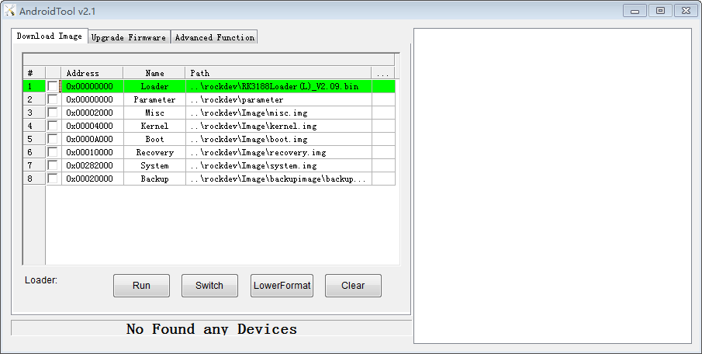

Click ***Upgrade Firmware,***you will have this interface

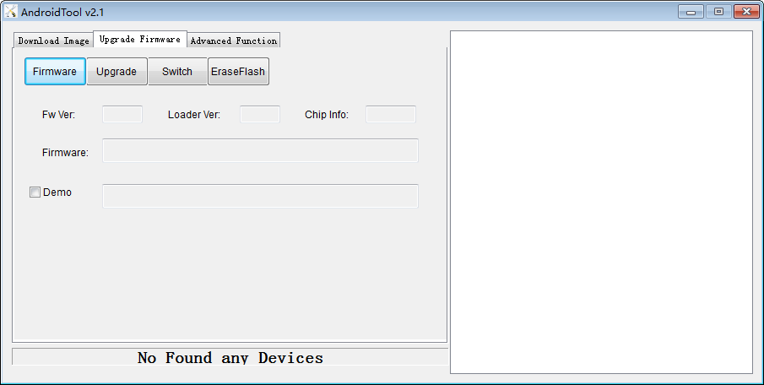

Click ***Firmware***, select the Android image you just downloaded

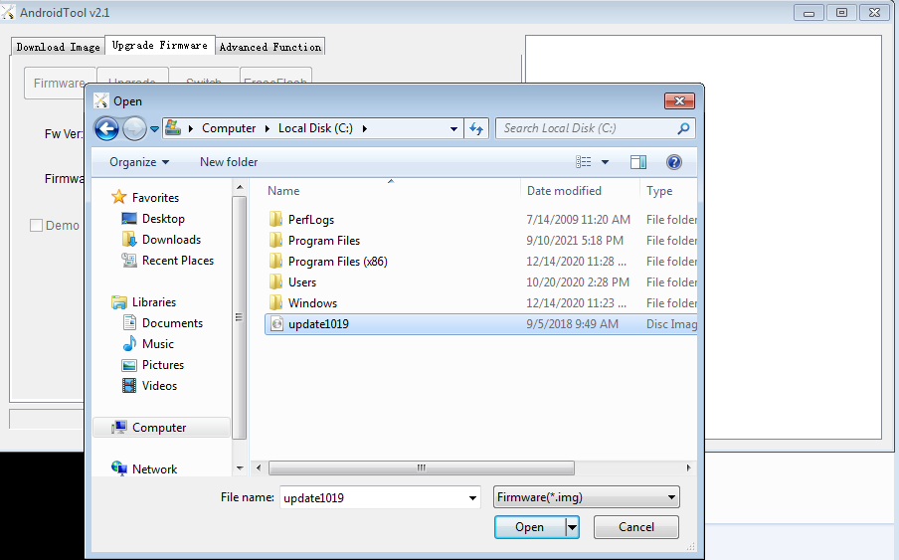

3.Connect USB burning cable to the computer with AndriodTool installed. Long press the upgrade button and connect the other side of the USB burning cable to the indicated USB port (beside the VGA) on the RK3288 board at the same time, and then connect power supply to the RK3288 board, release the upgrade button until the AndroidTool recognize the device.

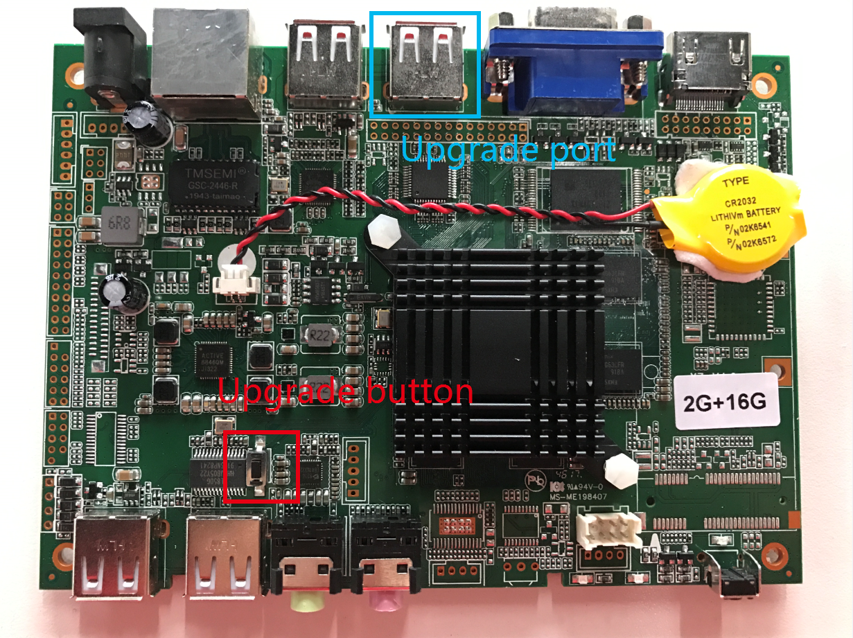

Click the ***Upgrade*** to start the upgrade

4.Remove the USB burning cable after Upgrade complete

